Table of Contents

List of Tables: 2

List of Figures: 2

1. Introduction and Literature Review 3

1.1. Introduction 3

1.2 Literature Review 4

2. Data 5

2.1. Retrieving Data 5

2.2. Filtering Data 5

2.3. Merging data 6

2.4. Transposing Data 6

2.5. Renaming and Cleaning Data 6

3. Methodology 7

3.1. Checking Stationarity 7

3.1.1. Stationarity Check: Visual Method 7

3.1.1. Stationarity Check: ADF Method 9

3.1.1.A. GDP Stationarity Check: ADF Method 9

3.1.1.B. Electric Power Consumption Stationarity Check: ADF Method 9

3.2. Making series stationary: 10

3.2.1. Applying transformation (First Lag differencing) 10

3.2.2. Checking for stationarity 11

3.3. Creating VAR Models 13

3.4. Selecting VAR Models (Information Criteria) 13

3.5. Running model with lag length from selection. 13

4. Results & Analysis 14

4.1. Running model summary 14

4.2. Running Granger Causality test. 15

4.2.1. Electric Power Consumption affects GDP. 15

4.2.1. GDP affects Electric Power Consumption. 15

5. Conclusion 16

6. Implication & Recommendation 16

References: 17

# List of Tables:

Table 1: Raw GDP data of U.S. sourced from World Bank website 5

Table 2: Raw Electrical power consumption data sourced from World Bank website. 5

Table 3: GDP of U.S. 5

Table 4: Electrical Power Consumption of U.S. 5

Table 5: GDP and Electrical Power Consumption merged. 6

Table 6: Transposed dataframe. 6

Table 7: Renaming columns and rows of dataframe. 6

# List of Figures:

Figure 1: Original GDP plot. 7

Figure 2: Original Electrical Power Consumption Plot. 8

Figure 3: Raw and Transformed GDP and Electricity Consumption Plot. 11

# 1. Introduction and Literature Review

## 1.1. Introduction

Every country faces a dilemma in decision making process, for an example how can the life of people can be improved. Various economist suggest that we need to first know how to measure people’s quality of life. The one common and easily used measurement is GDP.

GDP signify progress of nation hence; every country would like to increase their GDP. Any nation with higher GDP will need more resources for consumption and more energy in converting those resources for consumption. Consumption of energy can take place either by renewable or nonrenewable sources.

And energy from both this resource is mostly converted to electrical energy. So, a country’s total energy consumption can be measured simply by measuring its electrical consumption. Except that this measurement will not include energy from petrol, diesel, and coal used directly in engines.

But nevertheless, there is no evidence against the common sense that electricity increases standard of leaving and productivity of people (Yao, Luo, & Rooker, 2012 ).

Hence, we try to find relationship between electrical consumption and GDP of country.

Our goal here is to find whether GDP increases electrical power consumption or electrical power consumption causes increase in GDP. This project tries to solve this chicken and egg problem which parameter of country causes another affect. This will decide whether electrical consumption is input for higher GDP or it is merely an outcome of higher GDP.

This study can guide policy makers to make rational decision, rather than taking populist decision. What this research tries to achieve is to create a mathematical method to arrive at policy making process.

The reason our research can work is, because there is no guarantee for existence of symmetry in cause and effect of process.

Since data of country US is well documented since 1960, we choose US for our study. The data ranges from year 1960 to 2014.

## 1.2 Literature Review

This chicken and egg problem have been analyzed before by various researchers. A study (Alege, Adediran, & Ogundipe, 2016 )investigated between GDP per capita and electricity showed that that electricity causes more proportionate changes in GDP compared to C02. A similar study (Albiman, Suleiman, & Baka, 2015 ), conducted on Tanzania showed that both electricity consumption and economic growth rate LGDP causes C02 emission and that it was also found that electricity and CO2 emission causes a significant positive growth rate in the GDP, suggesting the government to increase electricity resource to increase the GDP of country. Similarly, a study Colombia, Ecuador and Mexico showed a unidirectional relationship between electricity and GDP. Another study (Majanga, 2015 ) on Malawi Power Sector discussed that availability of production resources like electricity increases the GDP growth and suggested for liberalization of resources to eliminate persistent power shortages. But few of the study (Matar & Bekhet, 2015 ) contradicted that it was the other way round where the increase in GDP causes increase in electricity consumption of countries like in the case of Jordan. And in one on case (Križanic & Oplotnik, 2013 ) suggested the that prices of electricity increases if GDP increases. On of this study suggested that China energy consumption per GDP was far greater than that of US and suggested for rest curing of the China’s energy consumption. In similar way in future we can expand our study to various other factors of nations to find relationship between electricity, GDP and other parameters of country. A similar study (Sultan, 2012 )done on Turkey, suggest that conserving electricity as a climate policy may not be conducive for exports and economic growth. he uses of renewable sources for electricity may be the right option.

Another study (Mabaso & Karodia, 2014 ) done in South Africa failed to reach any causality relationship. Another study (Ouedraogo, 2013 ) bifurcated the causality relationship to short and long run electricity usage and where it was discovered that, the causality is running from GDP to energy consumption in the short-run, and from energy consumption to GDP in the long-run.

Based on above literatures, we can say that we have two conditions to check for:

**1.2.1.** Does electric power consumption affect GDP?

H0: Electricity does not Granger causes GDP growth.  
 H1: Electricity Granger causes GDP growth.

**1.2.2.** Does GDP affect electric power consumption?

H0: GDP does not Granger causes electrical power consumption.  
 H1: GDP Granger causes GDP electricity.

# 2. Data

## 2.1. Retrieving Data

We retrieve two files (GDP and Electric Power Consumption) from world bank website and store them into two data frames. The data is shown as below:

Table 1: Raw GDP data of U.S. sourced from World Bank website

|  |  |  |  |  |  |  |  |  |
| --- | --- | --- | --- | --- | --- | --- | --- | --- |
| **Country.Name** | **Country.Code** | **Indicator.Name** | **Indicator.Code** | **X1960** | **X1961** | **⋯** | **X2017** | **X2018** |
| Aruba | ABW | GDP per capita (current US$) | NY.GDP.PCAP.CD | NA | NA | ⋯ | 25655.102 | NA |
| Afghanistan | AFG | GDP per capita (current US$) | NY.GDP.PCAP.CD | 59.77733 | 59.87815 | ⋯ | 550.0685 | NA |

Table 2: Raw Electrical power consumption data sourced from World Bank website.

|  |  |  |  |  |  |  |  |  |
| --- | --- | --- | --- | --- | --- | --- | --- | --- |
| **Country.Name** | **Country. Code** | **Indicator.Name** | **Indicator.Code** | **X1960** | **X1964** | **⋯** | **X2017** | **X2018** |
| Aruba | ABW | Electric power consumption (kWh per capita) | EG.USE.ELEC.KH.PC | NA | NA | ⋯ | NA | NA |
| Afghanistan | AFG | Electric power consumption (kWh per capita) | EG.USE.ELEC.KH.PC | NA | NA | ⋯ | NA | NA |

## 2.2. Filtering Data

From above we can see that files contain data of all countries, while we need data only for US. So, we filter both of our data frame to obtain following:

Table 3: GDP of U.S.

|  |  |  |  |  |  |
| --- | --- | --- | --- | --- | --- |
|  | **X1960** | **X1961** | **⋯** | **X2017** | **X2018** |
| **250** | 3007.123 | 3066.563 | ⋯ | 59927.93 | NA |

Table 4: Electrical Power Consumption of U.S.

|  |  |  |  |  |  |
| --- | --- | --- | --- | --- | --- |
|  | X1960 | X1961 | ⋯ | X2017 | X2018 |
| **250** | 4049.787 | 4182.176 | ⋯ | NA | NA |

## 2.3. Merging data

Both data (GDP, and Electric Power Consumption) are to be analyzed together, so it makes sense to merge above data frames, by which we obtain following:

Table 5: GDP and Electrical Power Consumption merged.

|  |  |  |  |  |  |
| --- | --- | --- | --- | --- | --- |
|  | **X1960** | **X1961** | **⋯** | **X2017** | **X2018** |
| **250** | 3007.123 | 3066.563 | ⋯ | 59927.93 | NA |
| **2501** | 4049.787 | 4182.176 | ⋯ | NA | NA |

## 2.4. Transposing Data

As we see know that timeseries data must have column represented by parameters rather than time, hence we transpose to data frame to obtain following:

Table 6: Transposed dataframe.

|  |  |  |
| --- | --- | --- |
|  | **250** | **2501** |
| **X1960** | 3007.123 | 4049.787 |
| **X1961** | 3066.563 | 4182.176 |
| **X1962** | 3243.843 | 4433.606 |
| **X1963** | 3374.515 | 4690.486 |
| **X1964** | 3573.941 | 4970.446 |
| **1965** | 3827.527 | 5234.685 |

## 2.5. Renaming and Cleaning Data

We rename columns 250 to gdp and 2501 to elec for easier referencing, also we rename each year by removing X from its first name.

Table 7: Renaming columns and rows of dataframe.

|  |  |  |
| --- | --- | --- |
|  | **gdp** | **elec** |
| **1960** | 3007.123 | 4049.787 |
| **1961** | 3066.563 | 4182.176 |
| **1962** | 3243.843 | 4433.606 |
| **1963** | 3374.515 | 4690.486 |
| **1964** | 3573.941 | 4970.446 |
| **1965** | 3827.527 | 5234.68 |

***Note: Everywhere in this document Electrical Power Consumption as elec and GDP as gdp.***

# 3. Methodology

## 3.1. Checking Stationarity

Before continuing our research, we first check whether both of our series is stationary, or do we need to transform them to make them stationary. A good quick way is to plot series and see if they are not making any pattern. Stationary series will never show a pattern.

### 3.1.1. Stationarity Check: Visual Method

On plotting GDP, we obtain following graph:

Figure 1: Original GDP plot.

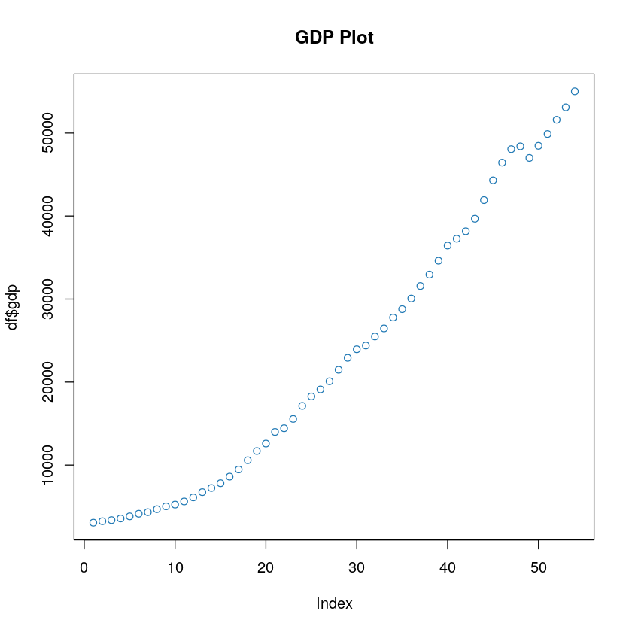

From above we see that GDP is showing an upward trend. Let us perform same test for electrical power consumption as for VAR modeling is expected that both time series data should be stationary.

On plotting Electrical Power Consumption, we obtain following graph:

Figure 2: Original Electrical Power Consumption Plot.

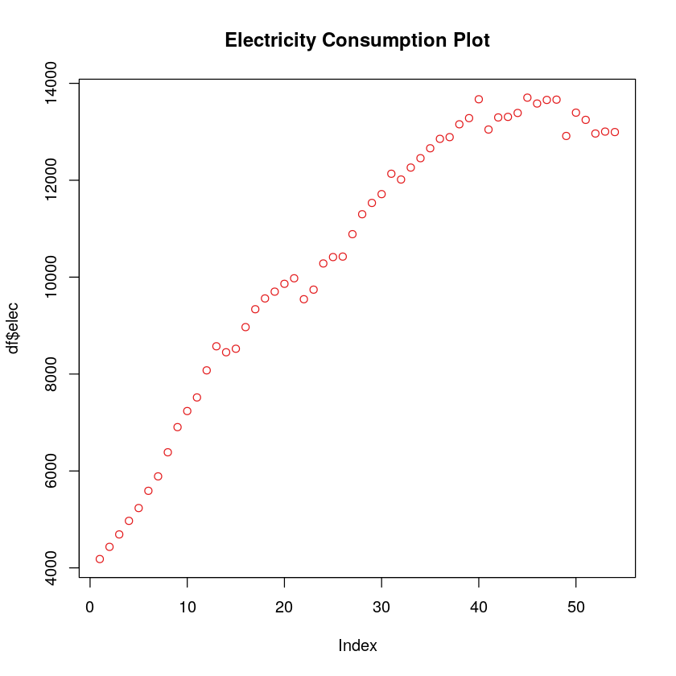

It seems that elec also shows upward trend. We could conclude here that both of this series are not stationary but a mathematical proof is always better to make such strong conclusion. Hence in next section we will perform another test for stationary.

### 3.1.1. Stationarity Check: ADF Method

Since we were unable to make clear conclusion from visual method, it seems that both of this series are not stationary. So, we perform ADF test.

ADF (Augmented Dickey–Fuller) test is used to find the unit root in time series. And presence of unit root nullifies the presence of stationarity in series.

Thus, for ADF test our:

* H0: Unit root present: Series is not stationary
* H1: Unit root not present: Series is stationary

Hence, we expect that our t-value to be lower (in left) of critical value so that we can reject our null hypothesis that series is not stationary and continue for VAR modeling

### 3.1.1.A. GDP Stationarity Check: ADF Method

Performing ADF test on GDP we obtain:

Output:

Critical Value: -2.89  
T Value: 2.1618

On performing ADF test on GDP, we see that t value (2.16) is to right of the critical value (-2.89), hence we cannot reject null hypothesis, thus this series is not stationary and we cannot proceed for VAR modeling as we will have to make stationary.

### 3.1.1.B. Electric Power Consumption Stationarity Check: ADF Method

Similarly, on performing ADF test on Electric Power Consumption we obtain:

Output:

Critical Value -2.89

T Value: -4.3814

On performing ADF test on Electric Power consumption, we see that t value(-4.38) is to left of the critical value(-2.89), hence we can reject null hypothesis, thus this series is stationary and we can proceed for VAR modeling as we will not have to make stationary.

But comparing difference as one parameter and actual values at one parameter will be a wrong comparison, hence all transformation to be applied on GDP will be applied to Electric power consumption from here ontt.

## 3.2. Making series stationary:

### 3.2.1. Applying transformation (First Lag differencing)

Although it is argued to take log of difference but taking log of difference is a two-step procedure and we will lose important information of our model on doing so.

Moreover, when we took log differencing, we did not obtained stationarity in GDP.

So, we will continue with simple differencing. The interpretation of such transformation is that does changes in GDP affects changes in Electric Power consumption. We perform same test again on the transformed series

The transformed series can be explained following equation:

For GDP:

$gdp1=gdp_{t}−gdp_{t−1}$

For Electrical Power Consumption:

$elec1=elec_{t}−elec_{t−1}$

### 3.2.2. Checking for stationarity

#### 3.2.2.1. Stationarity Check: Visual Method (First Lag Differences)

In order to proof that our transformation was successful, we will plot them along with original parameters plot.

Figure 3: Raw and Transformed GDP and Electricity Consumption Plot.

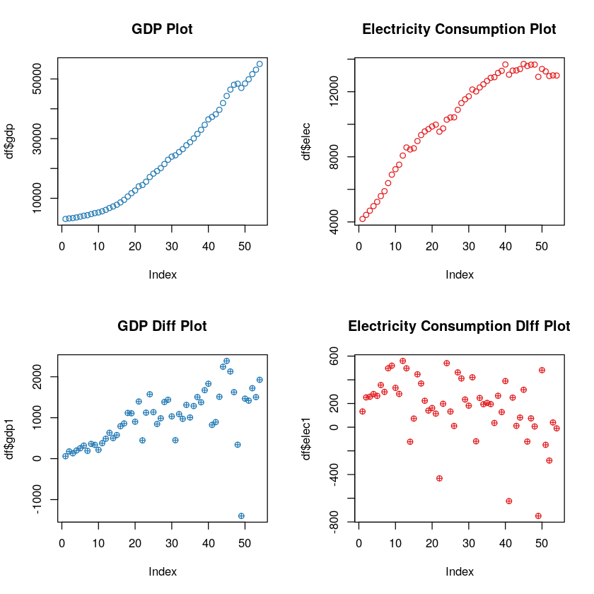

As we can see from above plots that GDP is not showing any clear trend and same can be said from electricity power consumption. But here again we will perform mathematical test to reinforce our conclusion.

#### 3.2.2.A. GDP Stationarity Check: ADF Method

Output:

Critical Value: -2.89

T value: -3.3569

On performing ADF test on GDP, we see that t value (-3.35) is to left of critical value (-2.89), hence we can reject null hypothesis, thus this series is now made stationary and we can proceed for VAR modeling.

#### 3.2.2.B. Electric Power Consumption Stationarity Check: ADF Method

Output:

Critical Value: -2.89

T Value: -4.3814

On performing ADF test on Electrical Power Consumption, we see that t value (-4.38) is to leave of the critical value (-2.89), hence we can reject null hypothesis, thus this series is now made stationary and we can proceed for VAR modeling.

## 3.3. Creating VAR Models

There can be different optimum model based on different model’s information criterion for selection. Following are those information criteria(s):

1. Akaike information criterion (AIC)
2. Bayesian information criterion (BIC) or Schwarz criterion (SC)
3. Final Prediction Error (FPE) criterion
4. Hannan–Quinn information criterion (HQC)

## 3.4. Selecting VAR Models (Information Criteria)

The choice of selecting a particular information criterion is out of scope of our study, we simply choose Schwarz criterion (SC) criterion most commonly known as BIC.

SC(n): 1

Based on selecting SC we obtain a model of type lag 1 which can be used to study Granger Causality.

## 3.5. Running model with lag length from selection.

While this step does not produce any output but is an important, nevertheless. In this step we pass lag=1 as parameter to VAR modeling. This model is saved for further result.

While our major part of our methodology ends here, now the next part involves result and analysis.

# 4. Results & Analysis

As mentioned earlier, that we have saved our model, hence we retrieve model summary to obtain following results.

## 4.1. Running model summary

We can make following conclusion after running model

**4.1.A.** For GDP equation:

$gdp={gdp}_{1}+{elec}_{1}+const$

1. $gdp_{1}$ is significant.
2. $elec_{1}$ is insignificant and can be ignored.
3. $const$ is significant

Hence, GDP is dependent only on lag of itself and not on lag of electricity power consumption.

**4.1.B.** For Electrical power consumption equation:

$elec={gdp}_{1}+{elec}_{1}+const$

1. $gdp_{1}$ is significant.
2. $elec_{1}$ is insignificant and can be ignored.
3. $const$ is significant.

Hence, Electrical Power consumption is dependent only on lag of GDP but not on its previous values.

The above analysis can be done in better way by using Granger Causality test. Hence in next portion we will perform Granger Causality test.

## 4.2. Running Granger Causality test.

### 4.2.1. Electric Power Consumption affects GDP.

Does electric power consumption affect GDP? We run the test with following assumption derived from section **1.2.1**. Literature Review:

H0: Electricity does not Granger causes GDP growth.  
 H1: Electricity Granger causes GDP growth.

Output:

p-value = 0.03126

Since, p-value is more than 0.05 we cannot reject the null hypothesis that electric power consumption does not affects the GDP, hence, electric power consumption does not affects the GDP, moreover it can be seen from **4.1.A.**, where coefficient of $elec_{1}$ is insignificant

### 4.2.1. GDP affects Electric Power Consumption.

Does GDP affect electric power consumption? We run the test with following assumption derived from section **1.2.2.** Literature Review:

H0: Electricity does not Granger causes GDP growth.  
 H1: Electricity Granger causes GDP growth.

Output:

p-value = 0.00673

Since, p-value is less than 0.05 we can reject the null hypothesis that GDP does not affects the electric power consumption, hence, GDP affects the electric power consumption moreover the same can be concluded from **4.****1.B.**

# 5. Conclusion

As we see that from **4.1.** while running model summary, that adjusted R square of our model is around .99 for both cases. Hence, we are in a good position to make very strong conclusion, though this large adjusted R square can be due to autocorrelation present in the model.

While **4.1.A. & 4.1.B.** was sufficient enough to derive our conclusion, but we still carried out Granger Causality test which gave same results.

In short, we conclude that:

Electrical Power Consumption GDP

GDP Electrical Power Consumption

As far as result are concerned it will be right to conclude that increase in electric power consumption will not increase GDP but the vice versa, i.e. increase in GDP will lead to increase in electric power consumption is true.

# 6. Implication & Recommendation

The possible reason could be that in case U.S., electricity consumption is not the main driver of GDP, while increase in GDP will create more demand for electricity consumption.

So, it is suggested that in order to increase the GDP. U.S. should not concentrate on amount of electricity consumption, but on various other factors. And on doing so if GDP increases, it will force the nation to consume more electricity.

An alternative way is thus not to give discounts on electricity but to make electricity available to more people and use the funds for other factor explaining standard of leaving.

It is thus recommended policy makers to not prioritize the electrical power consumption in order to increase GDP.

# References:

Albiman, M. M., Suleiman, N. N., & Baka, H. O. ( 2015 ). The Relationship between Energy Consumption, CO2 Emissions and Economic Growth in Tanzania . *International Journal of Energy Sector Management , 9* , 361-375. doi: 10.1108/IJESM-05-2014-0006

Alege, P. O., Adediran, O. S., & Ogundipe, A. A. ( 2016 ). Pollutant Emissions, Energy Consumption and Economic Growth in Nigeria: A Multivariate Granger Causality Framework . *International Journal of Energy Economics and Policy , 6* , 202-207.

Križanic, F., & Oplotnik, Z. J. ( 2013 ). Market Changes, Business Cycles and Fluctuations in Electricity Prices-EU Evidence from Germany and Slovenia . *International Journal of Energy Economics and Policy , 3* , 118-126.

Mabaso, S., & Karodia, A. M. ( 2014 ). An Evaluation of Factors Leading to Disequilibrium of Electricity Demand and Supply in Gauteng Province . *Nigerian Chapter of Arabian Journal of Business and Management Review , 2* , - .

Majanga, B. B. ( 2015 ). Liberalization of Utility Services in the Developing Countries: A Panacea to Economic Development? an Analysis on Malawi Power Sector . *Applied Economics and Finance , 2* , 110-118.

Matar, A., & Bekhet, H. A. ( 2015 ). Causal Interaction among Electricity Consumption, Financial Development, Exports and Economic Growth in Jordan: Dynamic Simultaneous Equation Models . *International Journal of Energy Economics and Policy , 5* , 955-967.

Ouedraogo, N. S. ( 2013 ). Energy Consumption and Economic Growth: Evidence from the Economic Community of West African States (ECOWAS) . *Energy Economics , 36* , 637-647. doi: 10.1016/j.eneco.2012.11.011

Sultan, R. ( 2012 ). An Econometric Study of Economic Growth, Energy and Exports in Mauritius: Implications for Trade and Climate Policy . *International Journal of Energy Economics and Policy , 2* , 225-237.

Yao, S., Luo, D., & Rooker, T. ( 2012 ). Energy Efficiency and Economic Development in China . *Asian Economic Papers , 11* , 99-117. doi: 10.1162/ASEP_a_00147